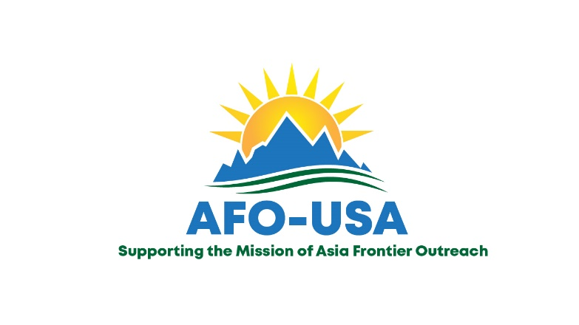
Privacy Policy
Updated January 14, 2023

We highly value the trust you put in Asia Frontier Outreach-USA, Inc.(AFO-USA). Therefore we take very seriously the protection of the personal and financial information shared with us over our website, at https://asiafrontieroutreach.com. We have developed this policy to have protocols in place to protect your personal information, and for you to understand what information we collect, how it is stored, and how it is used.
What personally identifiable information is collected from you online
Personal Information—we may collect personal information from you when you sign-up online for an event or program, to receive our emails, to receive SMS texts, to participate in a Facebook group or respond to a post, or make a donation.
- Our website host is Weebly, through Flipcause, our Customer Relationship Management(CRM) system. For their privacy policy, https://help.flipcause.com/help/data-privacy. When you sign-up for our emails, your name and email address are entered in our Constant Contact account. For Constant Contact’s Privacy Policy: https://knowledgebase.constantcontact.com/articles/KnowledgeBase/5536-constant-contact-privacy-policies-for-protecting-customers?lang=en_US
- Constant Contact Reporting measures the new contacts, opens, click throughs, and unsubscribes of our readers. In these reports your name, email address, and phone number is revealed only to the AFO-USA, Inc. administrators at the Constant Contact Account.
- When you make a donation to Asia Frontier Outreach-USA, Inc. online, your name, address, email address, phone number, credit card information and the amount of your donation is processed through a third-party processing center, Flipcause.
- Whatever personal information you may share on Facebook is available to us when you respond to a post on “Asia Frontier Children’s Hope” or participate in our Facebook group “AFO and Friends.”

What personally identifiable information is collected from you through your device.
- Our website may use technologies such as cookies, web beacons, pixels, and other similar technologies to automatically collect certain information from your device including, for example, your IP address, date and time of your visit, browser and operating system information, referring website address, and other information about how you interact with the website
- Our website may also use cookies and similar technologies to enhance your user experience.
- Our email campaigns may also use tracking technologies such as web beacons, pixels and other similar technologies to automatically collect certain information such as your IP address, browser type and version, and email engagement statistics.

Non-Personally Identifiable Information
We use Google Analytics to measure how website users interact with our site content. This information is collected solely for statistical purposes and does not include any information that can personally identify you.

How we Use Your Personal Information
We may use information collected about you for any lawful purpose, including the following:
- We use your name and address to send you information by postal mail about the programs of Asia Frontier Outreach-USA, Inc.
- We use your email address, with your consent, to send you emails
- We use your phone number to make a thank-you call. With your consent, we may text you.
- We may solicit a donation by postal mail or email.

Disclosure of Your Personal Information
We may share the information we collect with our business partners, including the following:
- Flipcause, our Customer Relationship Management(CRM) system, who is our donation payment processor and hosts financial and analytical data processing
- With Constant Contact, to send email and text message communications. For more
information about how we may use your information with Constant Contact and the
information that may be collected through our email campaigns, see Constant Contact’s
Customer Data Notice available at https://www.constantcontact.com/legal/customer-contact-
data-notice.
- We may share information that has been de-identified or aggregated without limitation.
Our website and social media platforms may offer interactive features, such as the ability to leave reviews, that you can use to communicate with other website visitors or to submit and post your own content. If you disclose information in one of these forums, this information can be viewed, collected, and used by others.

Type of Information we do not Collect or Disclose
We do not collect or store your credit card information in Asia Frontier Outreach-USA, Inc. data base.
We do not share your personal information with any entities, other than those listed above.
We do not sell your personal information to any entities.

Your Access to and Control over Information
You retain the right to control your data. At any time you can do the following:
- See what data we have about you, if any
- If you have a donation account with us, you may log into your account to change/correct/delete any personal or financial data we have about you. You can access your account through the link on your latest receipt from Flipcause.
- Express any concern you have about our use of your data
- Provide or withdraw consent for data collection and marketing.

EMAIL AND TEXT MESSAGE COMMUNICATIONS
- If you wish to unsubscribe from our email campaigns, please click on the Unsubscribe link at the bottom of any email sent from us. If you opt out of our emails, we will also remove you from our postal mail data base. Any end-of-year tax receipts that you are due will be mailed to you in January of the following year.
- If you wish to stop receiving text messages from us, reply STOP, QUIT, CANCEL, OPT-OUT, or UNSUBSCRIBE to any text message sent from us. For more information, see our Mobile Messaging Terms and Conditions

You may contact us at afo@asiafrontieroutreach.com with any of the above concerns.

CHANGES TO THIS PRIVACY POLICY
We may update this Privacy Policy at any time. Please review it frequently.

Security
We take precautions to protect your personal information both online and offline. Only staff who need the information to perform a specific job are granted access to personally identifiable information. The computers/servers in which we store your information are kept in secure environments.

